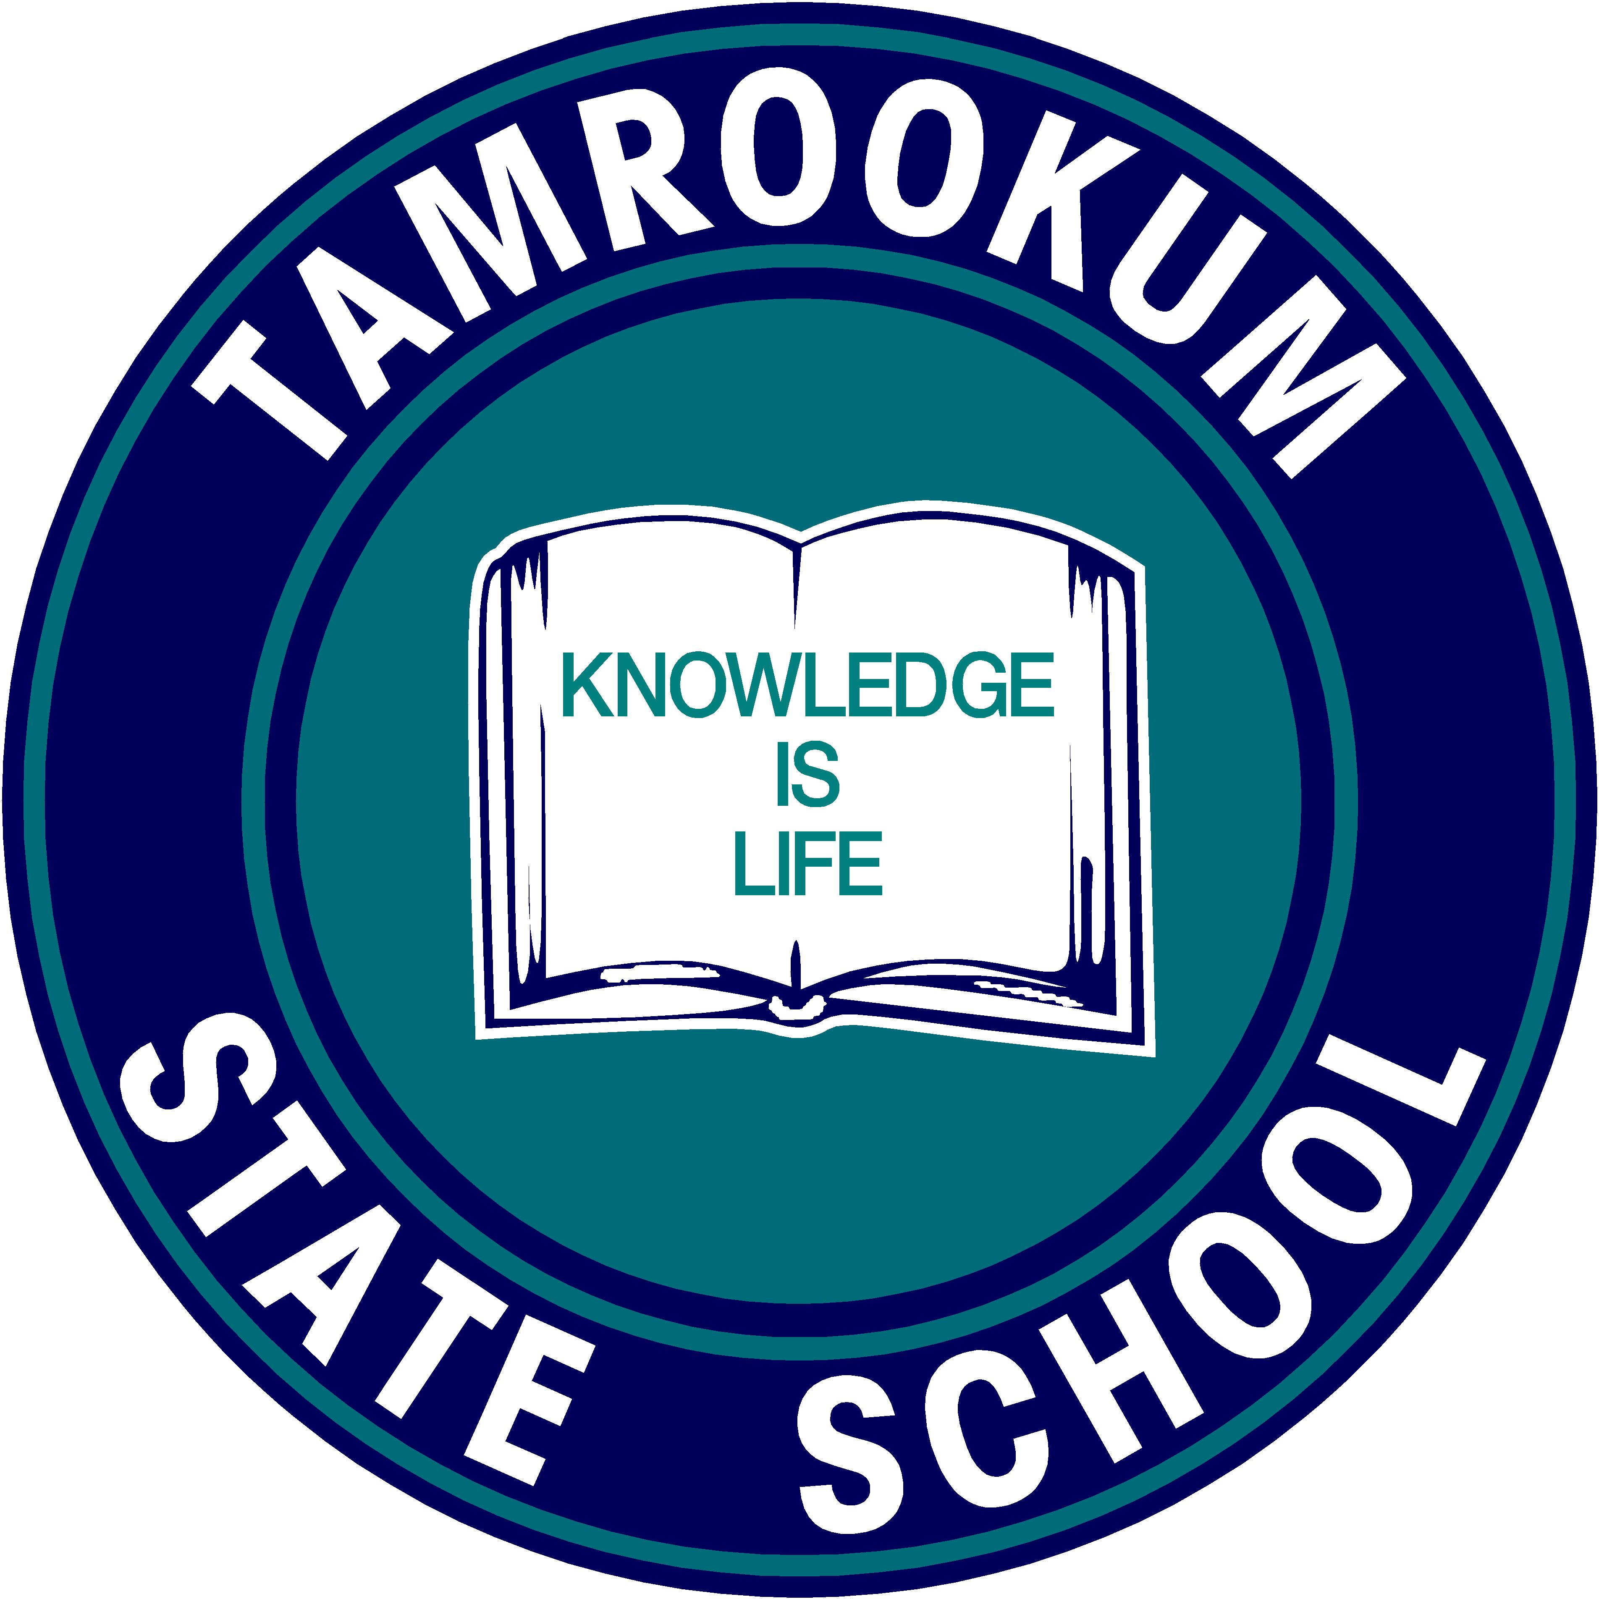
TAMROOKUM STATE SCHOOL

Knowledge is Life

9019 Mt Lindesay Highway
Beaudesert QLD 4285
Phone 07 5544 2555

4-Year Strategic Plan (2021-2024)
Vision:
Tamrookum State School aims to cultivate a learning community where all students are empowered to achieve their personal best. We are committed to creating an inclusive, collaborative, and evidence-based environment that supports both student growth and staff development.

Key Improvement Strategies Based on the 2020 School Review:

1. Strengthen a Whole-School Approach to Explicit Instruction and Feedback
Goal:
To implement a consistent, whole-school approach to explicit instruction and the use of feedback to enhance student learning outcomes.
Strategies:
- 2021: Develop a professional learning program to enhance teachers' understanding and application of explicit instruction and feedback models (aligned with Lyn Sharratt’s work on effective pedagogy).
- 2022: Implement school-wide routines for explicit instruction and embed them into planning and practice, focusing on consistency across all year levels.
- 2023: Conduct regular classroom observations and learning walks to monitor the use of explicit instruction, providing timely feedback to teachers.
- 2024: Review and refine instructional approaches based on data, feedback, and student performance, ensuring continuous improvement.
Outcomes:
- Improved teacher capacity in delivering explicit instruction.
- Greater consistency in instructional practices across the school.
- Increased student engagement and academic performance.

2. Enhance Staff Capacity in Data Literacy
Goal:
To build the capacity of staff to effectively analyse and utilise data to inform teaching practices and improve student outcomes.
Strategies:
- 2021: Provide targeted professional development on data literacy, focusing on how to interpret and act on student achievement data.
- 2022: Implement regular data discussions within teaching teams to review student progress and adjust teaching strategies as needed.
- 2023: Establish a collaborative data-sharing culture where teachers share best practices and interventions based on data insights.
- 2024: Use data-informed decision-making to differentiate instruction for all students, ensuring every child’s learning needs are addressed.
Outcomes:
- Teachers confidently using data to inform planning and instructional adjustments.
- Improved student outcomes due to tailored teaching approaches.
- A school-wide culture of continuous improvement based on evidence.

3. Build a Collaborative Learning Culture
Goal:
To create a culture of collaboration where staff, students, and the community work together to improve learning outcomes.
Strategies:
- 2021: Develop Professional Learning Communities (PLCs) to foster collaboration among teachers focused on student learning and instructional practices.
- 2022: Promote collaboration between students through peer-to-peer learning, group projects, and reflective practices that enhance metacognition.
- 2023: Strengthen partnerships with parents and the broader community through regular communication, feedback loops, and involvement in school events.
- 2024: Review the effectiveness of collaborative practices and refine processes to ensure sustainability and continual improvement in learning outcomes.
Outcomes:
- Stronger collaboration between teachers, leading to more innovative teaching practices.
- Enhanced student engagement through collaborative learning experiences.
- Increased community involvement in supporting student success.

Evaluation and Monitoring:
Throughout the 2021-2024 period, we will monitor the progress of our strategic goals through:
- Regular reviews of student achievement data.
- Feedback from staff, students, and the community.
- Annual reflection on the implementation of key strategies and their impact on student outcomes.
By 2024, Tamrookum State School aims to have established a culture of continuous improvement where every student is given the opportunity to succeed academically and socially.

